SOCIETY REIMBURSEMENT GUIDE

1. Should a Society require reimbursing please fill out an Expenses Claim Form as shown in the below picture:
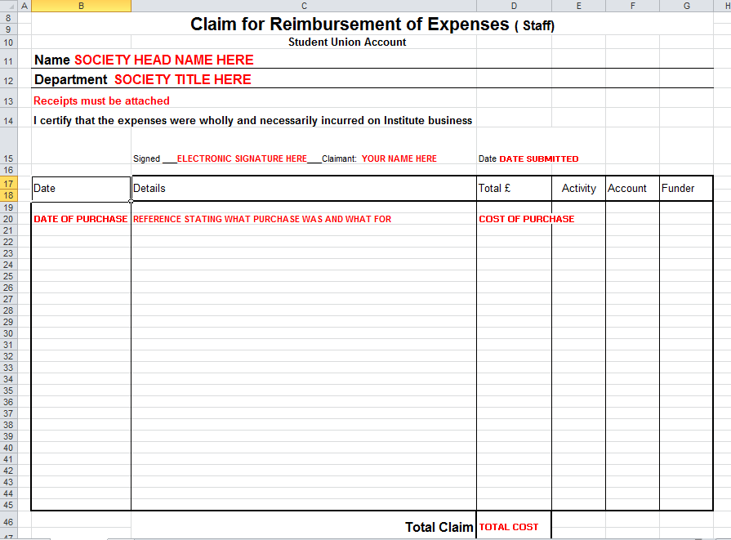
2. Sign form using an electronic signature. Use one of the methods below to create an electronic signature if you have not already:
Sign your name on a piece of blank paper.

Then two options:

Option 1
- Scan the paper and save on your computer – it will be a pdf document.
- The signature can then be highlighted (right-click on the mouse) and copied on other Word documents.

Option 2
2. Take a picture of your signature with your mobile phone and email it to yourself.
3. The signature can then be edited and copied on other Word documents.

3. Remember to fill out your bank details at the bottom of the claim form in order for reimbursements to be sent directly to your account.

4. Email completed form to students.union@courtauld.ac.uk for it to be approved by the President and authorised by Finance. It may take a few days for the reimbursement to reach your account.

